User Manual for Reimbursement Report Generator

# Intro

Welcome to the Reimbursement Report Generator! This application helps you create, manage, and save reimbursement reports for your expenses. The program consists of three main components:

1. **Main Application Window**: Launches the application and provides options to create a new report or close the application.
2. **Reimbursement Report Form**: Allows you to input report details, add expenses, and generate a Word document report
3. **Popup Message Window**: Displays a message confirming that a report has been created and provides options to start a new report or close the popup and return to current report window

# Getting Started

**1. Launching the Application**

* Run the **'mainwindow.py'** script to start the application. This will open the main application window.

# Main Application Window

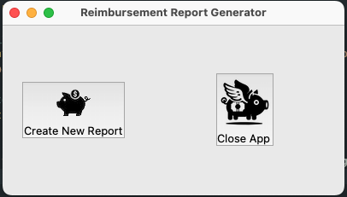

The main application window presents two options:

* **Create New Report:** Opens a new window with reimbursement report form to enter information and expense details.
* **Close App:** Closes the main application window and exits the program

## Button Functions:

* **Create New Report:**
  + Click this button to open a new instance of the **"Reimbursement_Form"** window where you can enter details about your reimbursement.
* **Close App:**
  + Click this button to exit the application.

# Reimbursement Report Form

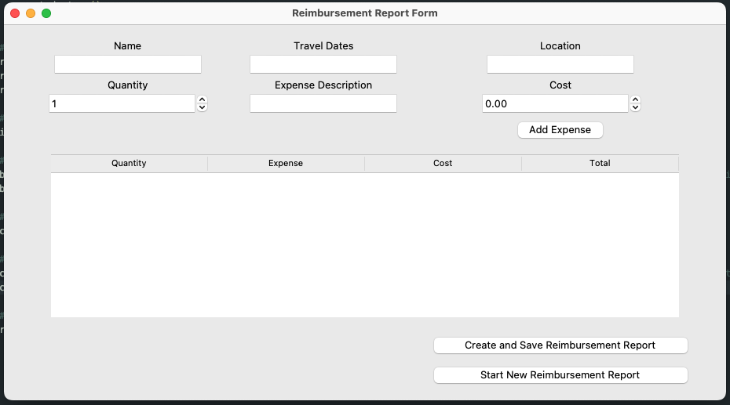

In the **Reimbursement_Form** window, you can input your reimbursement details, add expenses, and generate a report. The form consists of the following sections:

## Input Fields

* **Name**: Enter your name.
* **Travel Dates**: Input the travel dates in the format **MM/DD/YYYY-MM/DD/YYYY**.
* **Location**: Enter the location or name of conference or expense location

## Expense Details

* **Quantity**: Use the spinbox to specify the quantity of items.
* **Expense Description**: Enter a brief description of the expense.
* **Cost**: Specify the cost of the expense by typing in the expense or using the spinbox.

## Action Buttons

* **Add Expense**:
  + Click this button to add the entered expense to the list displayed below. The expense details are validated before being added.
* **Create and Save Reimbursement Report**:
  + Click this button to generate and save a Word document report. After saving, a popup window will appear.
* **Start New Reimbursement Report**:
  + Click this button to clear the current form and prepare for a new report.

## Expense Display

* **Treeview**: Displays a list of added expenses with columns for Quantity, Expense Description, Cost, and Total.

# Popup Message Window

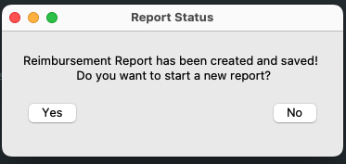

After creating and saving a report, a popup window will appear with the following options:

* **Yes**:
  + Click this button to close the popup and start a new reimbursement report. This will open a new **“Reimbursement_Form”** window.
* **No**:
  + Click this button to close the popup and return to the current form.

# Detailed Steps for Common Tasks

## Creating a New Reimbursement Report

1. **Open the Main Application Window**:
   * Launch the application and click on "Create New Report".
2. **Enter Report Details**:
   * Fill in your name, travel dates, and location.
3. **Add Expenses**:
   * Enter the quantity, description, and cost of each expense and click "Add Expense" to add it to the list.
4. **Generate the Report**:
   * Click "Create and Save Reimbursement Report". The application will generate a Word document and display a popup window.
5. **Respond to the Popup**:
   * Choose to either start a new report or close the popup.

## Starting a New Report

1. **After Saving a Report**:
   * When the popup window appears, click "Yes" to start a new report.
2. **Fill Out the New Report Form**:
   * Enter new details and add expenses as needed.

## Closing the Application

1. **From the Main Application Window**:
   * Click "Close All Windows" to exit the application.

# Troubleshooting

* **Input Validation Errors**:
  + Ensure all required fields are filled out correctly. Check the format of the travel dates and make sure all numerical entries are positive and valid.
* **Popup Not Appearing**:
  + Ensure that the report was saved correctly. If the popup does not appear, verify that the **popupmessage** module is functioning correctly.
* **Application Does Not Launch**:
  + Make sure all required libraries (**tkinter, docxtpl, re, popupmessage**) are installed. You can install missing libraries using **pip install <library-name>**.
  + Make sure that all libraries (**Tkinter, docxtpl**) are up to date. Sometimes issues arise from outdated or incompatible versions.
  + Ensure that the script files and any referenced resources (like images or templates) are in the correct directory and accessible.